**Sunrise Fill-in-the-Blanks**

Write a Fill in the Blank program (similar to the one in the [Print Input Lesson](/cip5/learn/print-input)). Your program should request three strings from the user:

1. a color
2. an adjective
3. a goal you would like to achieve

The story should then fill in the template:

At dawn the sky turned [color], and the air felt [adjective]. I decided today I will finally [goal].

Here is an example run of the program:

Here is another example run of the program:

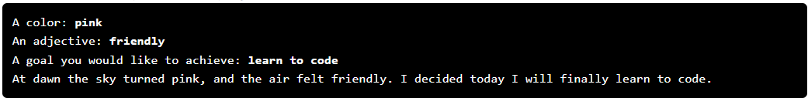

Note that the autograder is really particular about formatting. Your input prompts must be exactly:

